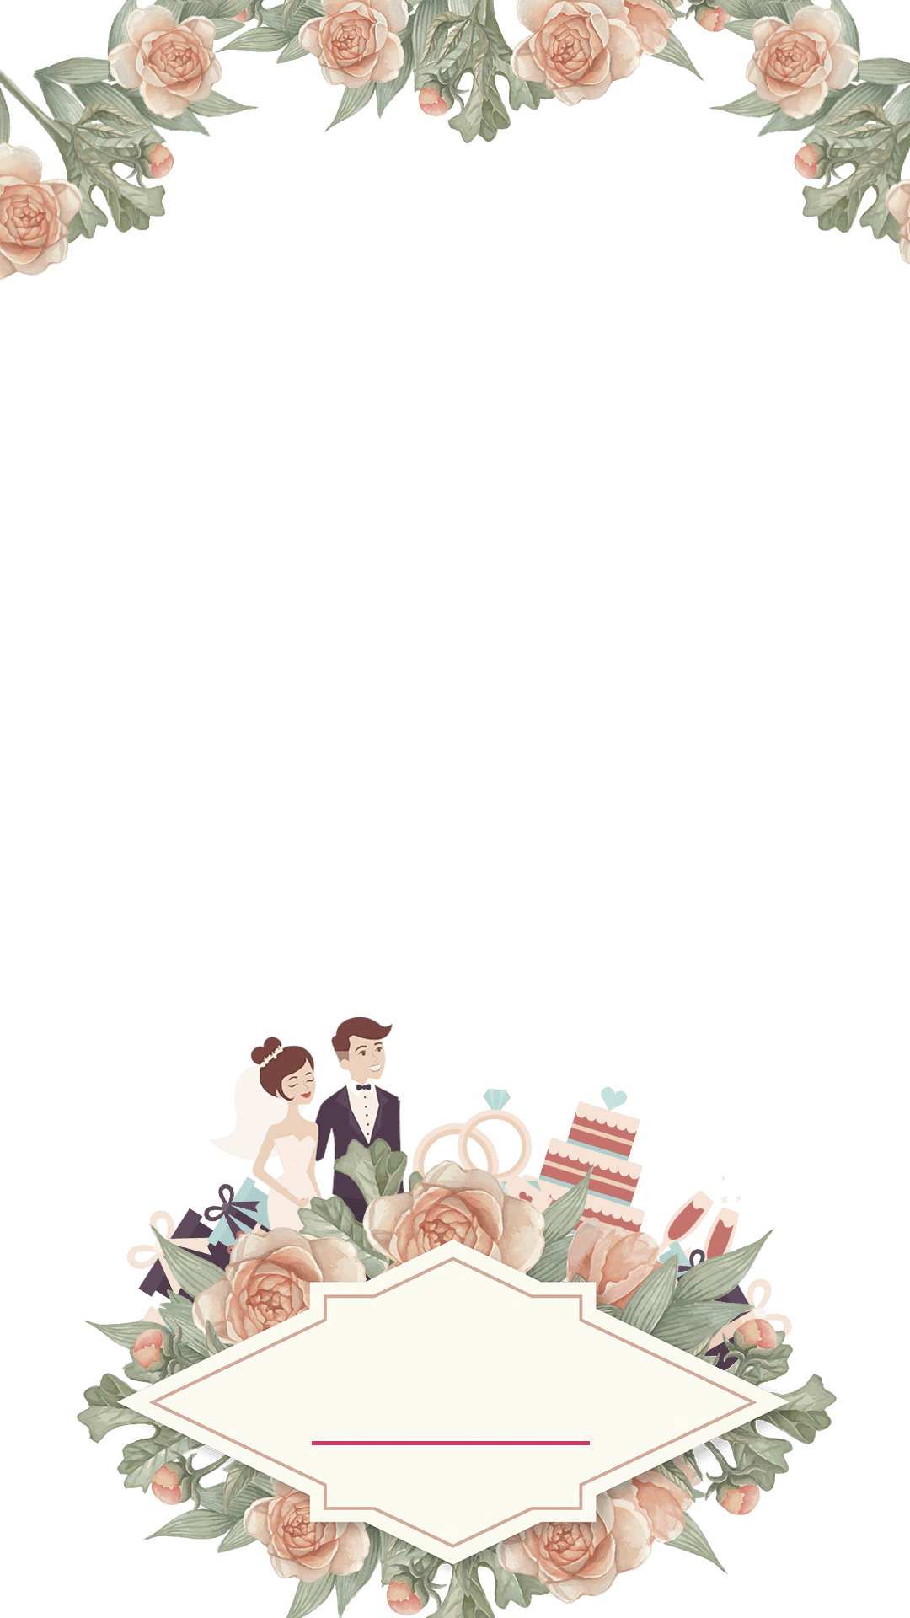

**Ceremony**

**Wedding Processional – (write here)**

**Welcome & Opening Prayer**

Lorem ipsum dolor sit amet. Et inventore earum qui assumenda quia quo velit quae. Sit sunt blanditiis indoors blanditiis eum nihil sunt ad facilis nisi non ullam perspiciatis repellat sequi ad facilis nihil qui numquam fuga ut magni sequi qui earum mollitia et nihil harum. Aut temporibus quam et perspiciatis consectetur ut numquam laborum sed voluptas laboriosam eos provident fuga. In adipisci ipsum est fugit quasi aut voluptas sint.

**Mr. and Mrs. Edward Williams**

**joyfully invite you to join them**

**AT THE MARRIAGE OF THEIR DAUGHTER**

**Branson**

**&**

**Lauren**

**Son of Mr & Mrs Tyler Wilson**

**SATURDAY. THE TWENTY – FOUR OF MARCH**

**at hall past three o’clock in the afternoon**

**TWO THOUSAND TWENTY-THREE**

**St . Peters CHURCH**

**Ash Church Road, Ash, Surrey, GU12**

**Reception to follow**