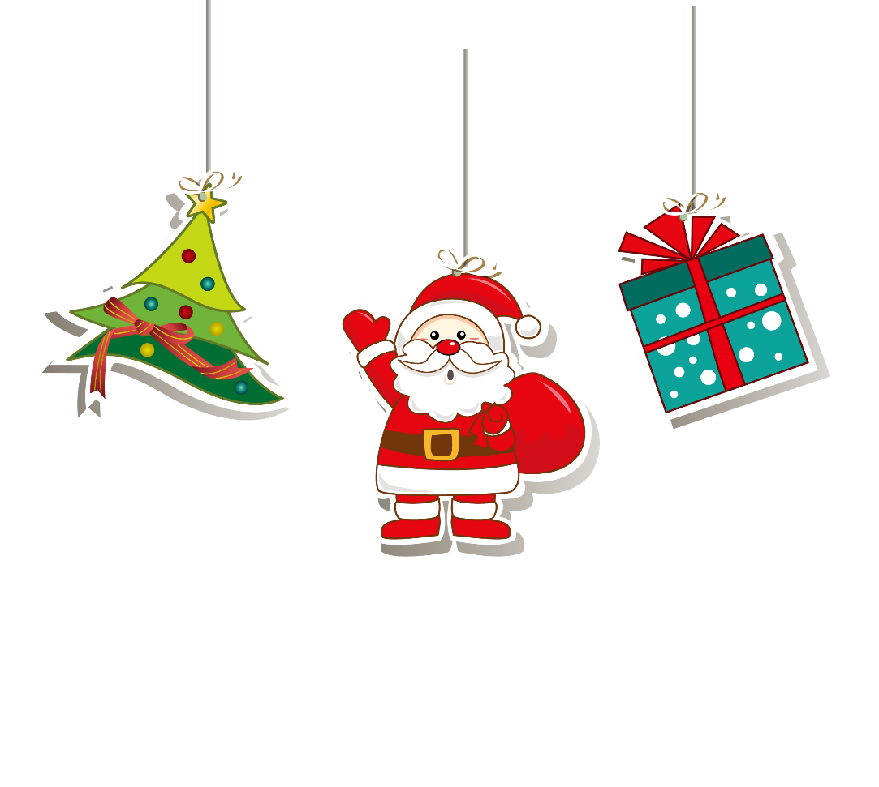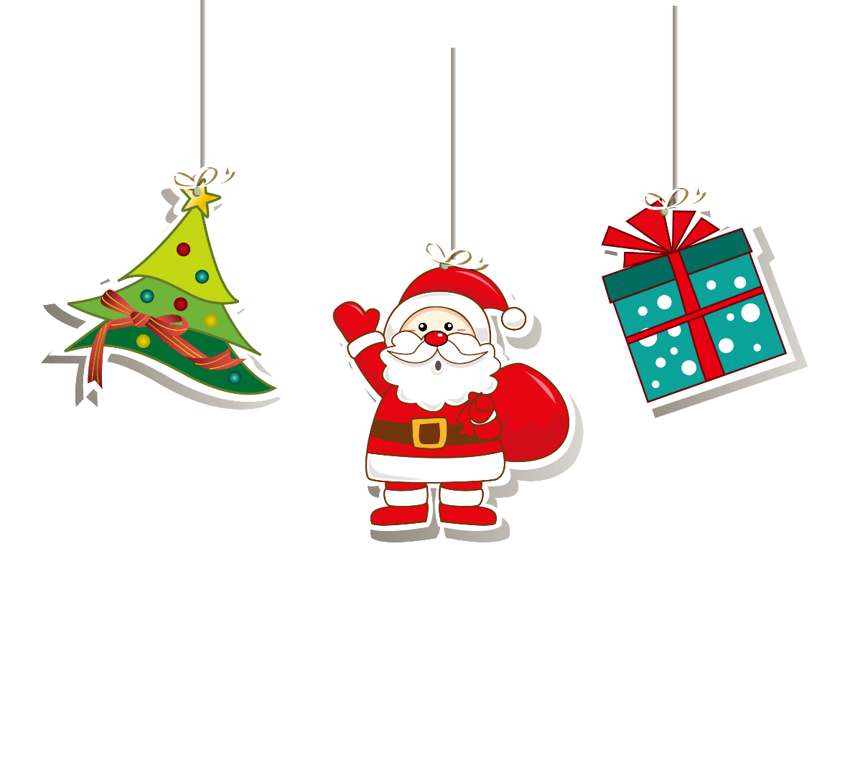

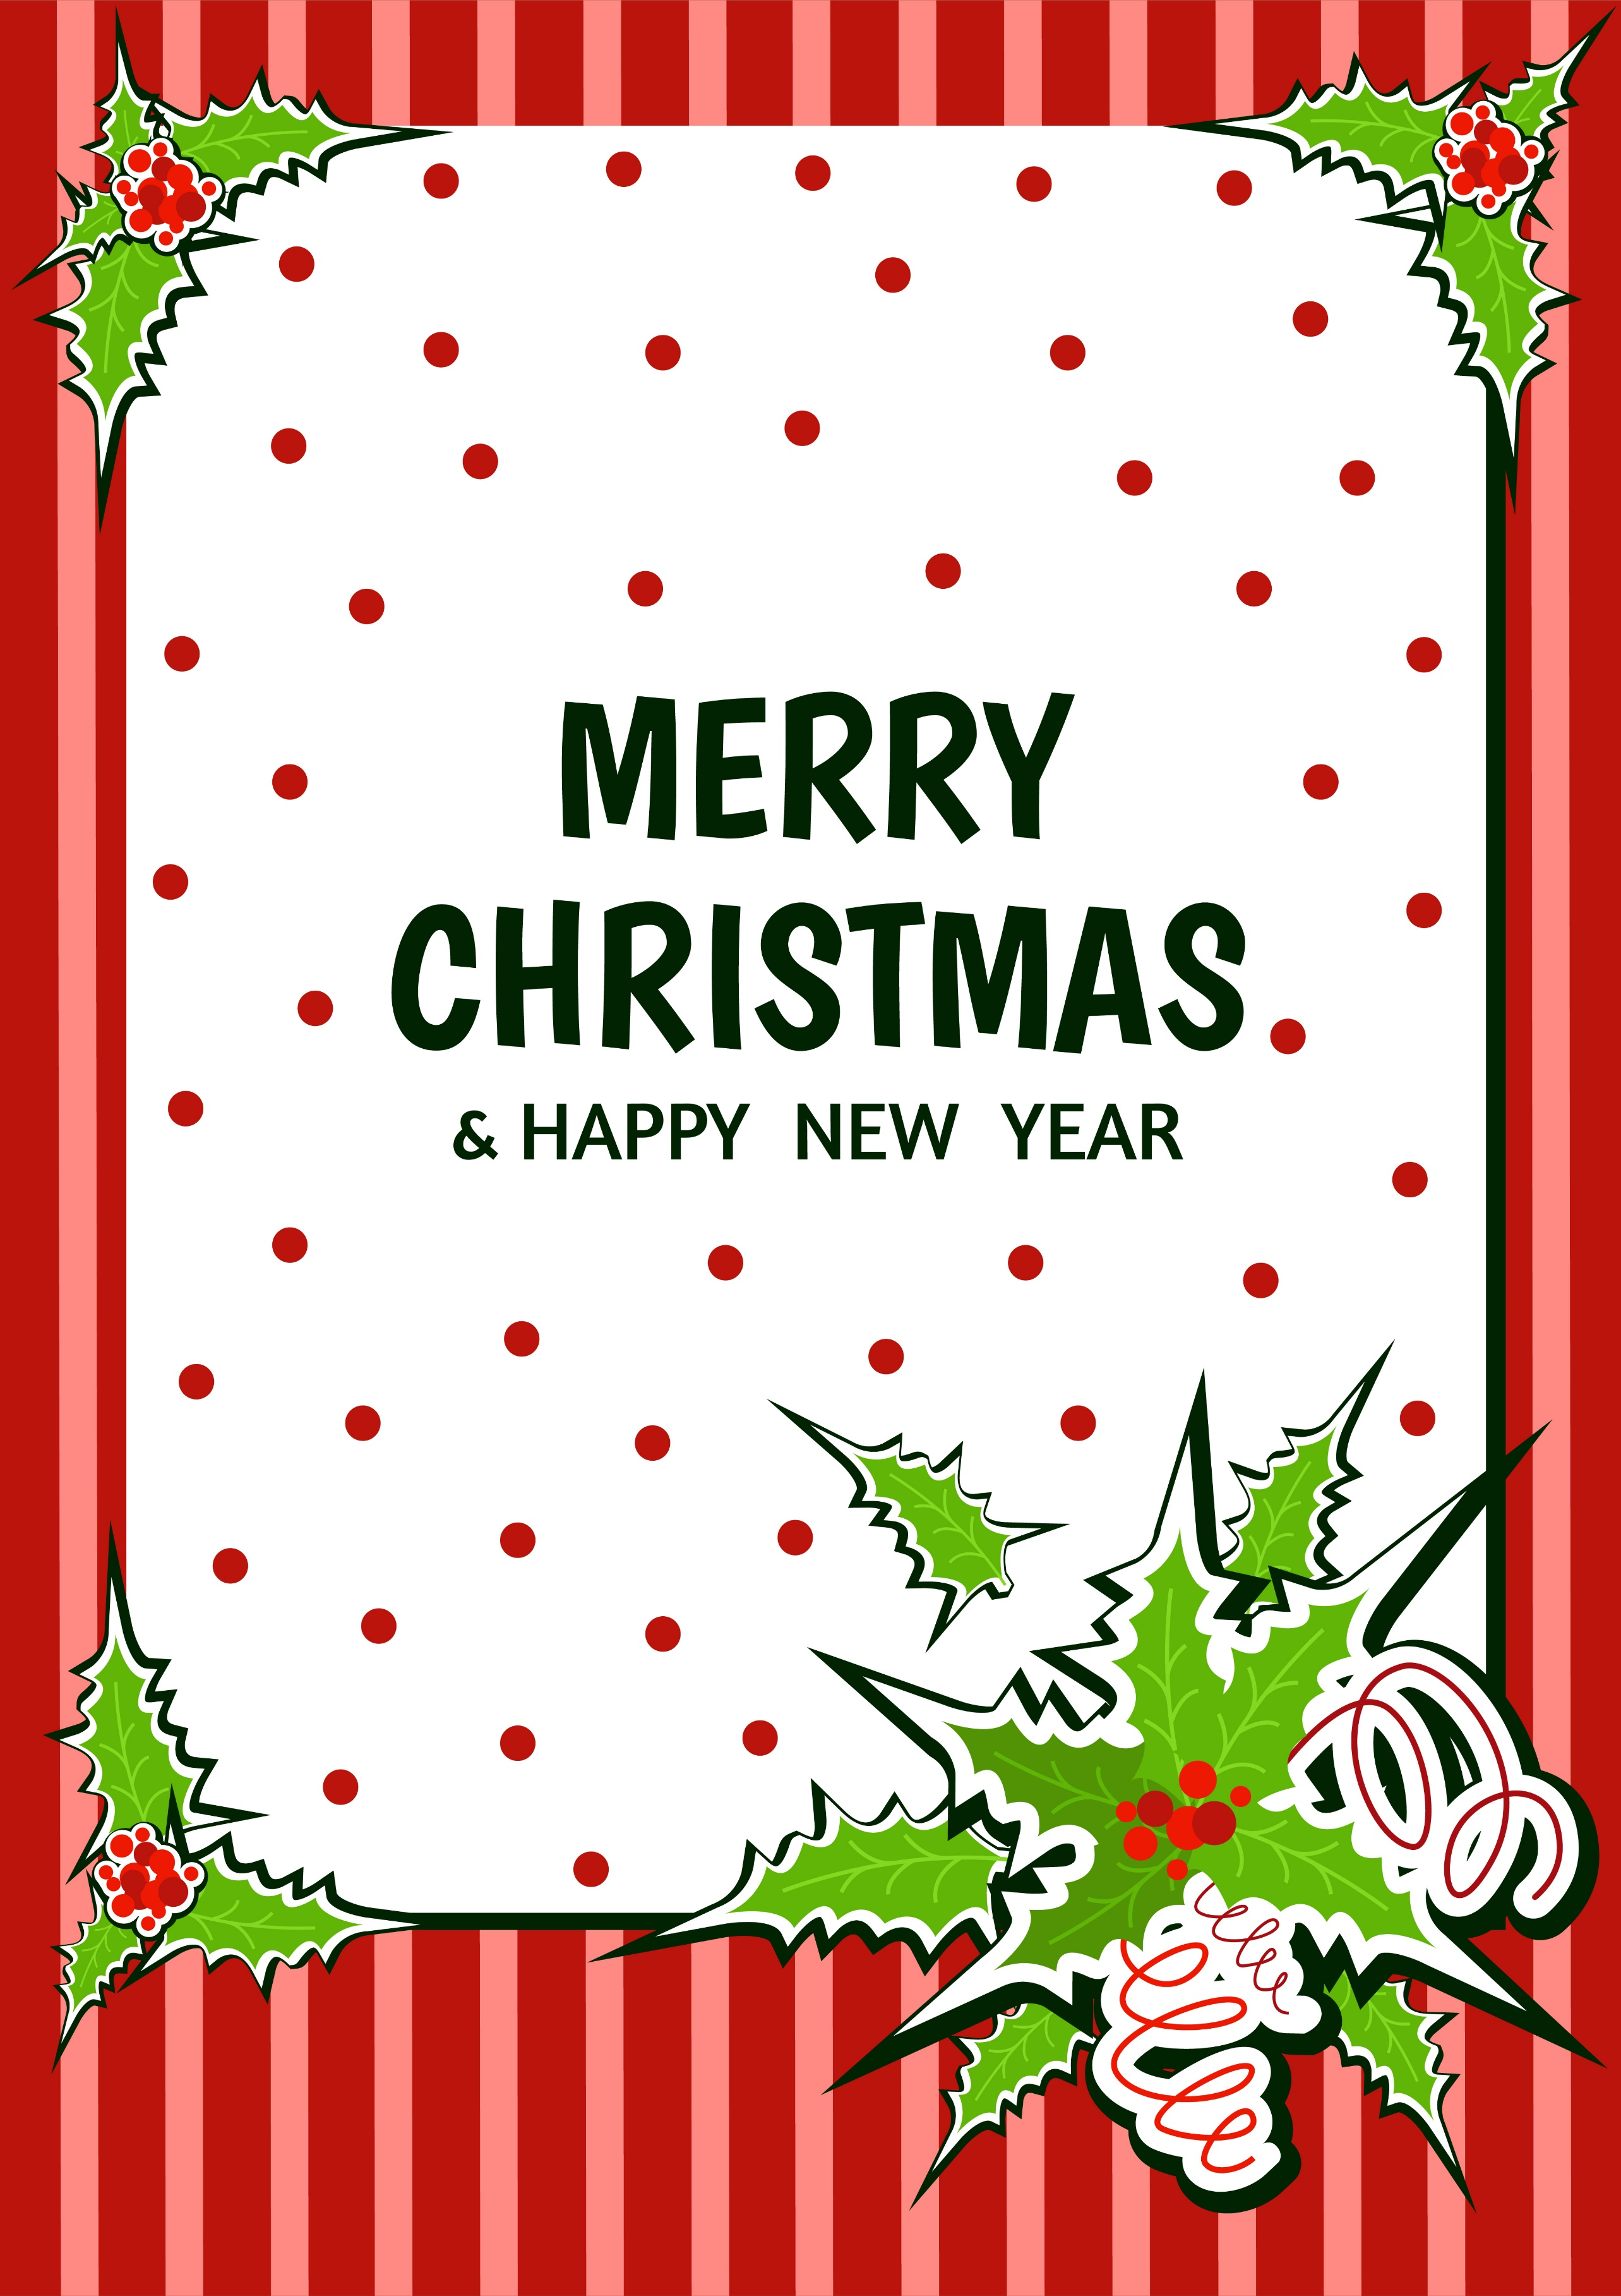

**My Christmas Wish List**

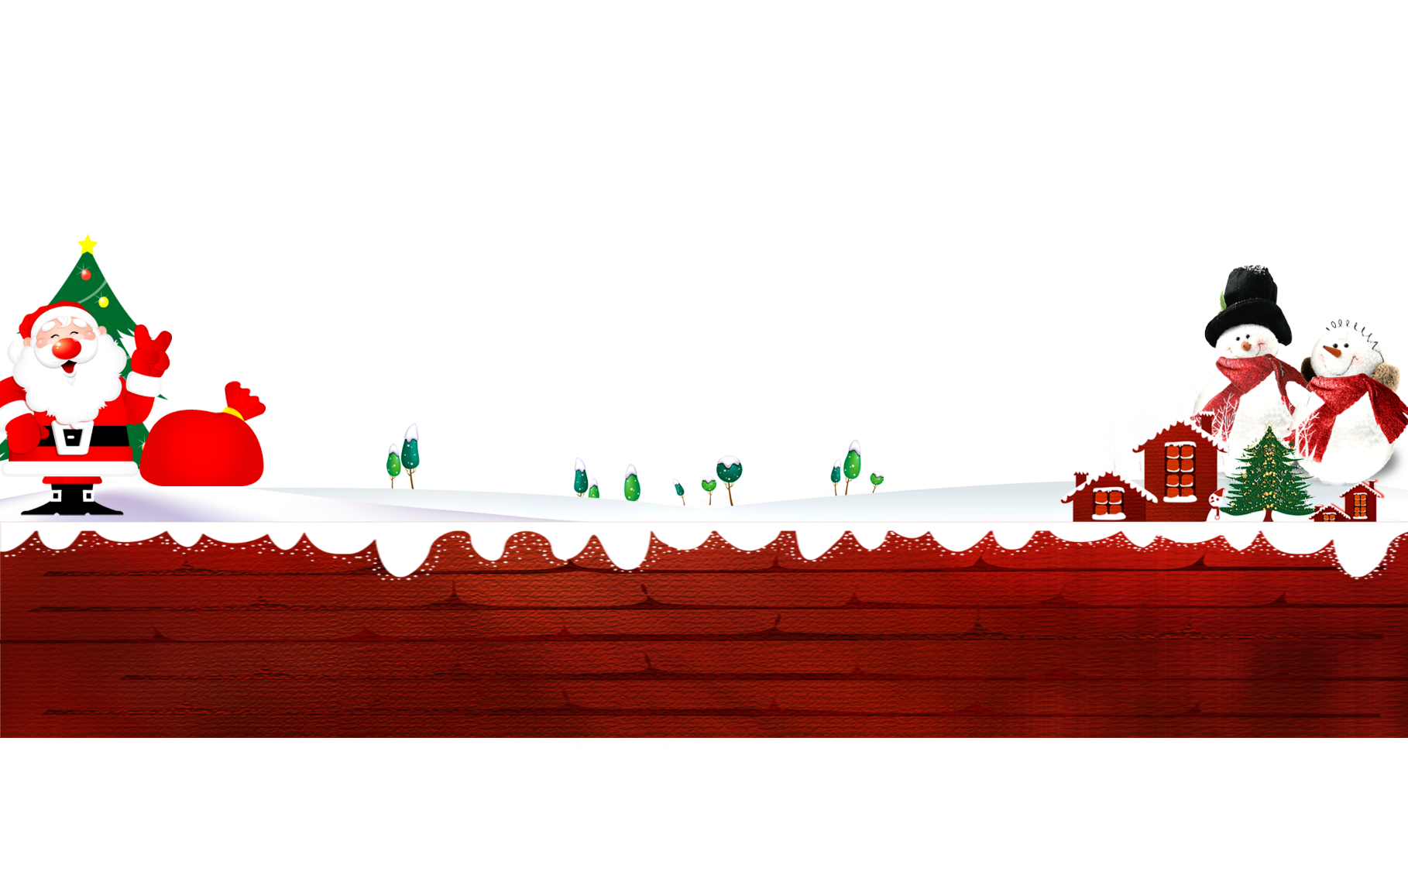

|  |  |  |
| --- | --- | --- |
| **Name:** |  | **Things I would Like to Have:** |
| Favorite Color 1: |  |  |
| Favorite Color 2: |  |  |
| Favorite Candy: |  |  |
| Favorite TV Show: |  |  |
| Favorite Movie: |  |  |
| Favorite Animal: |  |  |
| Favorite School Subject: |  |  |
| Favorite Hobby: |  |  |
| Favorite Sport: |  |  |
| Favorite Book: |  |  |
| Favorite Cereal: |  |  |
| Favorite Snack: |  |  |
| Favorite fun thing to do: |  |  |
| Favorite place to shop: |  |  |
| Something I collect: |  |  |
| Favorite song/singer/band: |  |  |
|  |  |  |
| Favorite Inside Activity: |  |  |
| Favorite Outside Activity: |  |  |
| Something I want to know more about: |  |  |
|  |  |  |
| What I want to be when I grow up: |  |  |
|  |  |  |
| 2 Gifts I want the most: |  |  |
|  |  |  |
|  |  |  |