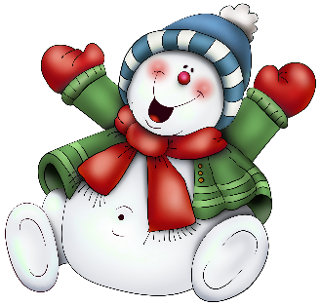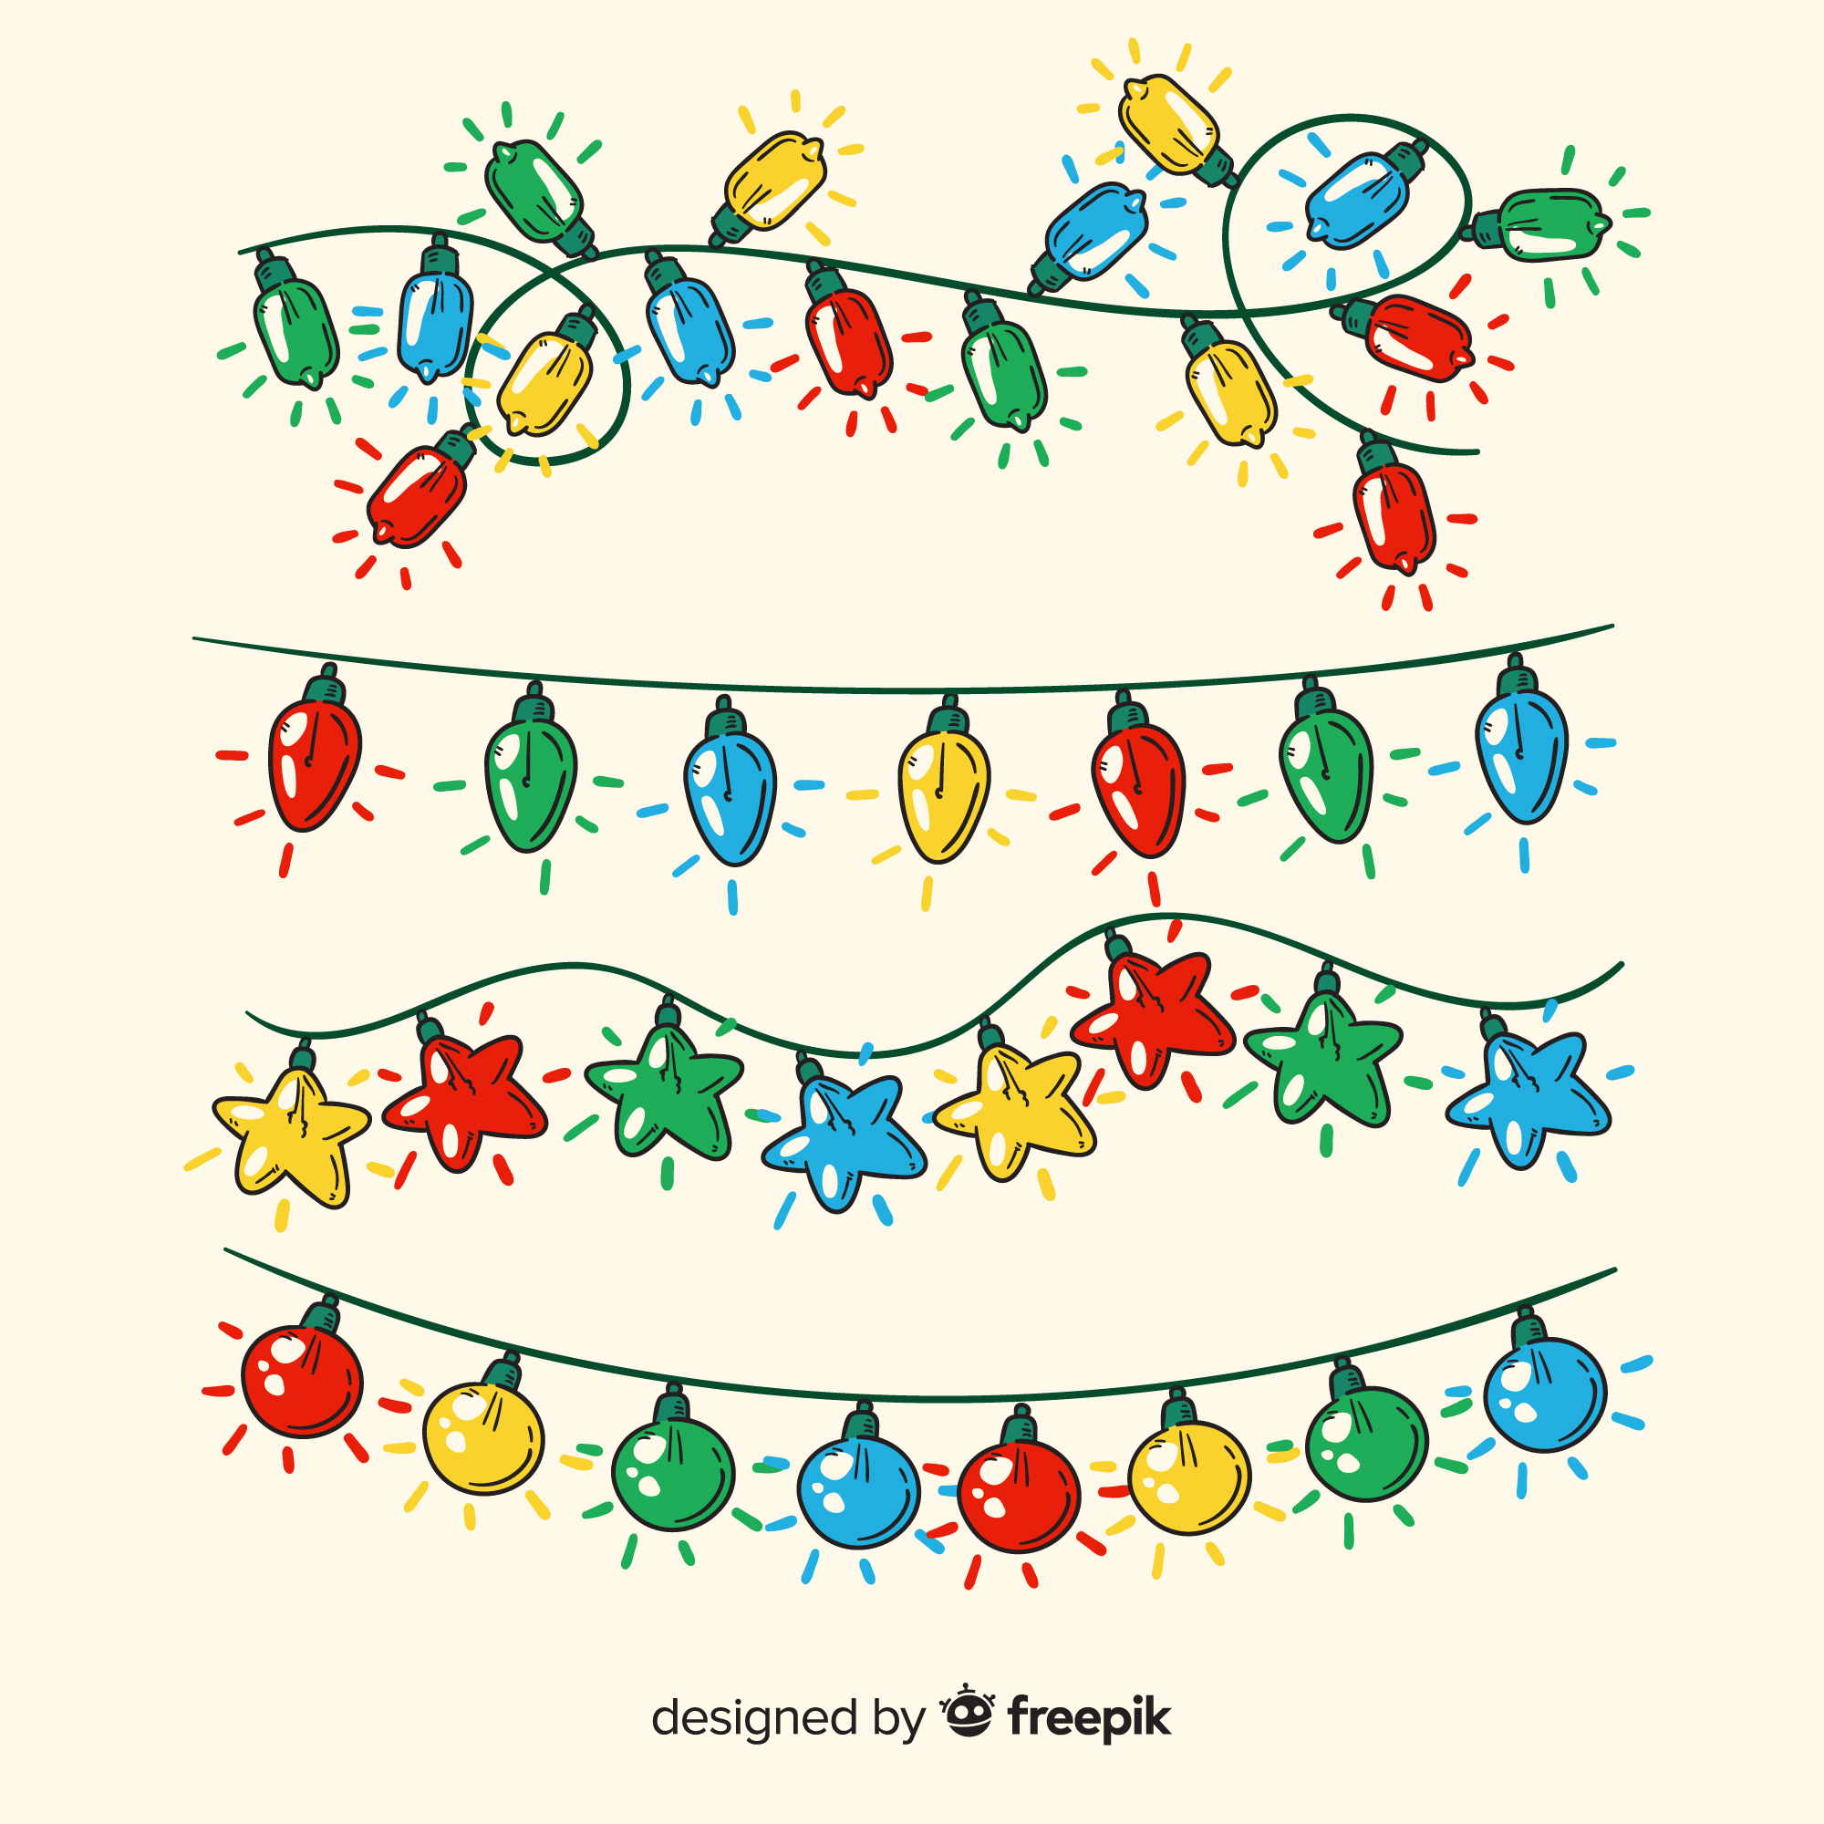

**This year of Christmas I would Like**

**Christmas Wish List**

**People to Shop for**

**My Favorite Things**

**Don’t forget**

**My “Santa’s” Are:**

**Gift of kindness:**

**Stocking Stuffers**

