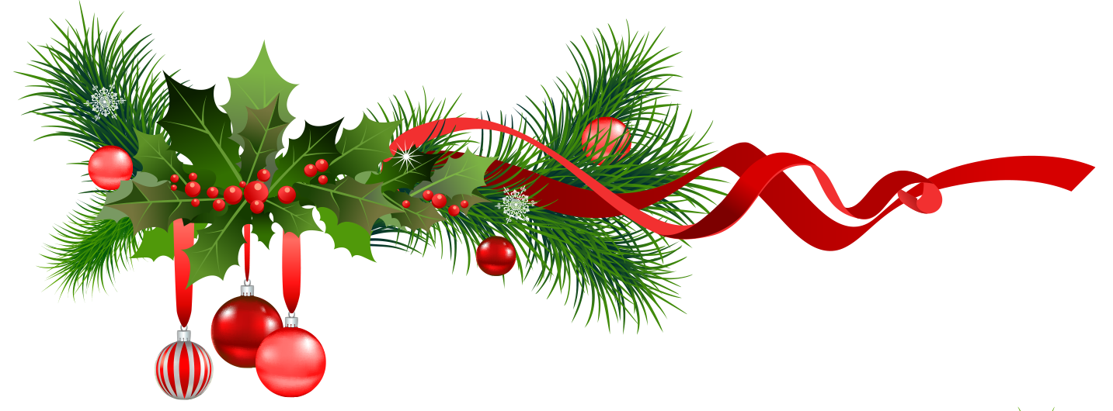
Christmas Wish List
My Favorite Things
_____________________________________
_____________________________________
_____________________________________
_____________________________________
_____________________________________
_____________________________________
_____________________________________
_____________________________________
People to Shop for
__________________________________________
Names: __________________________________________
__________________________________________Budget:
__________________________________________
__________________________________________
Gifts Chosen:
__________________________________________
__________________________________________
My “Santa’s” Are:
Name: ________________________________
Relationship: __________________________
Phone: _______________________________
Email: ________________________________

Don’t forget
__________________________________________
__________________________________________
__________________________________________
__________________________________________
__________________________________________

Stocking Stuffers:
__________________________________________________________________
________________________________________________________________

