
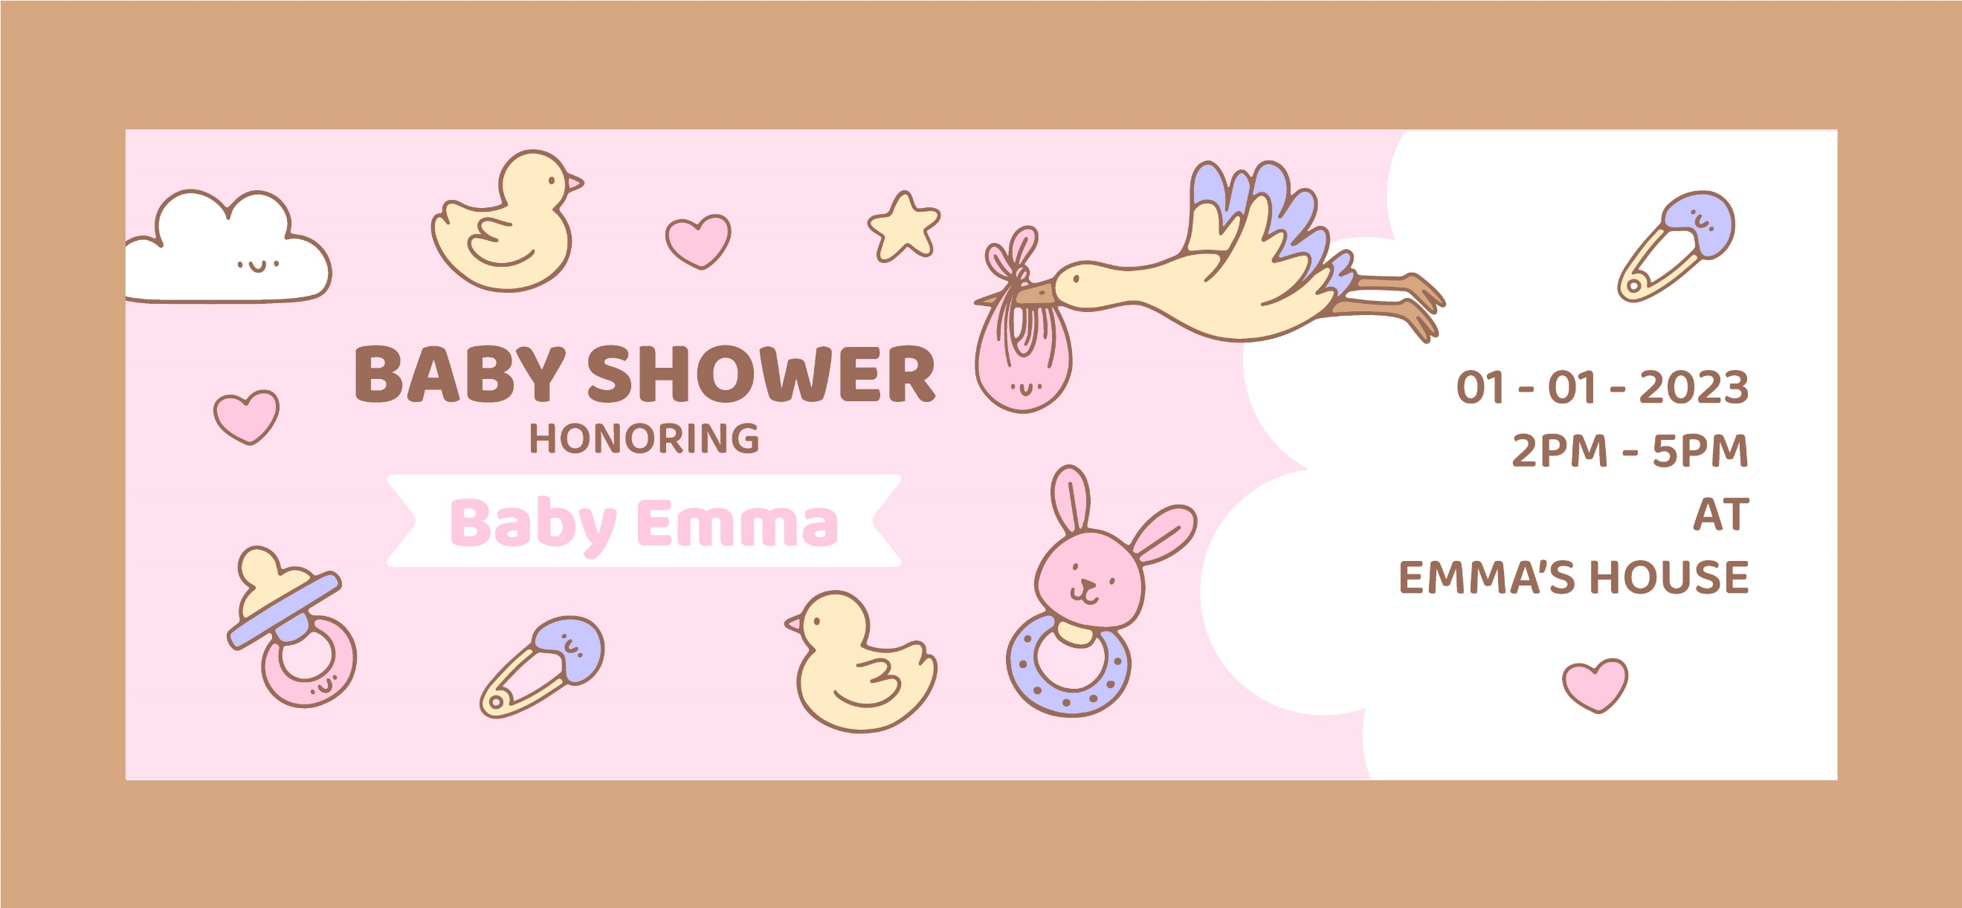
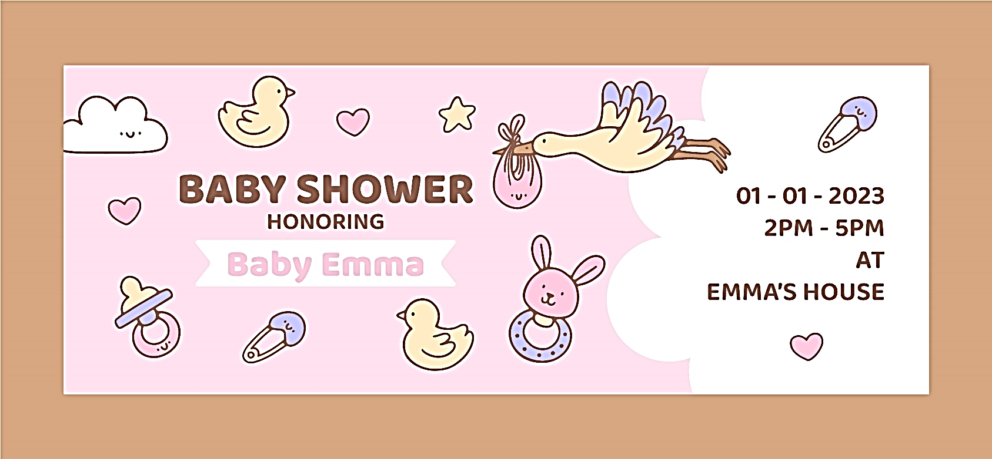
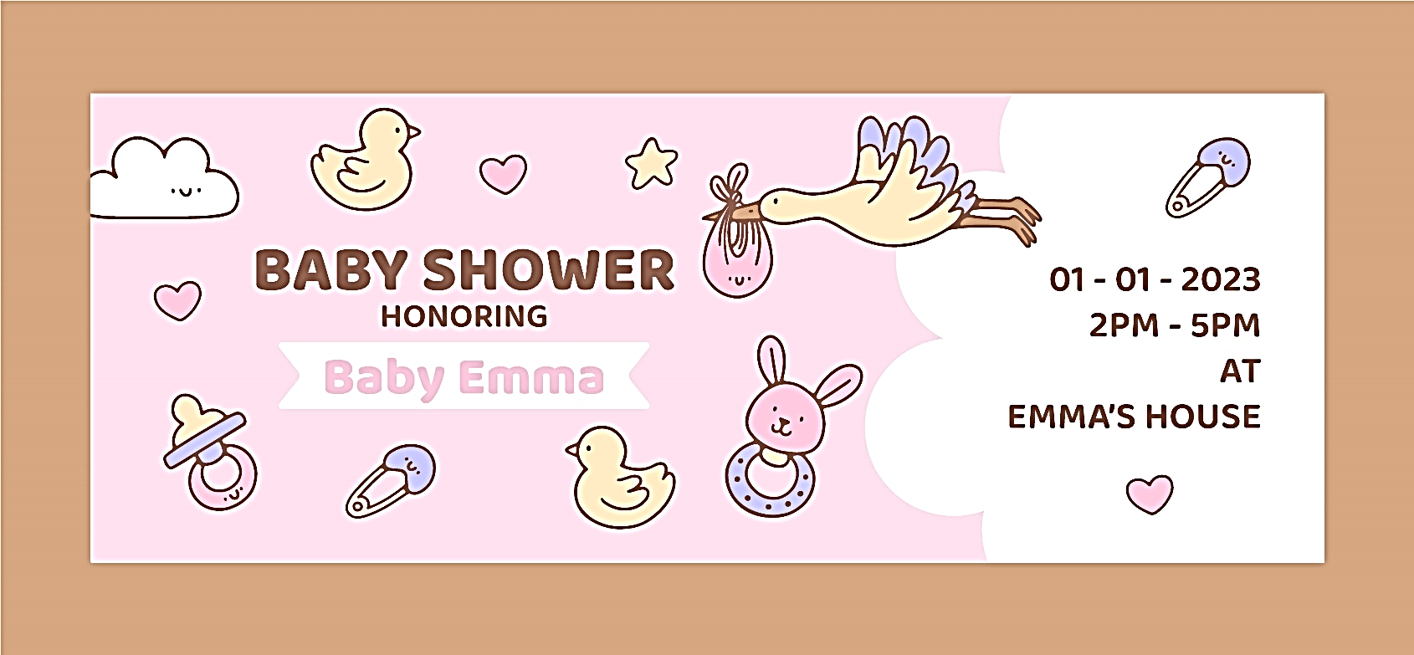
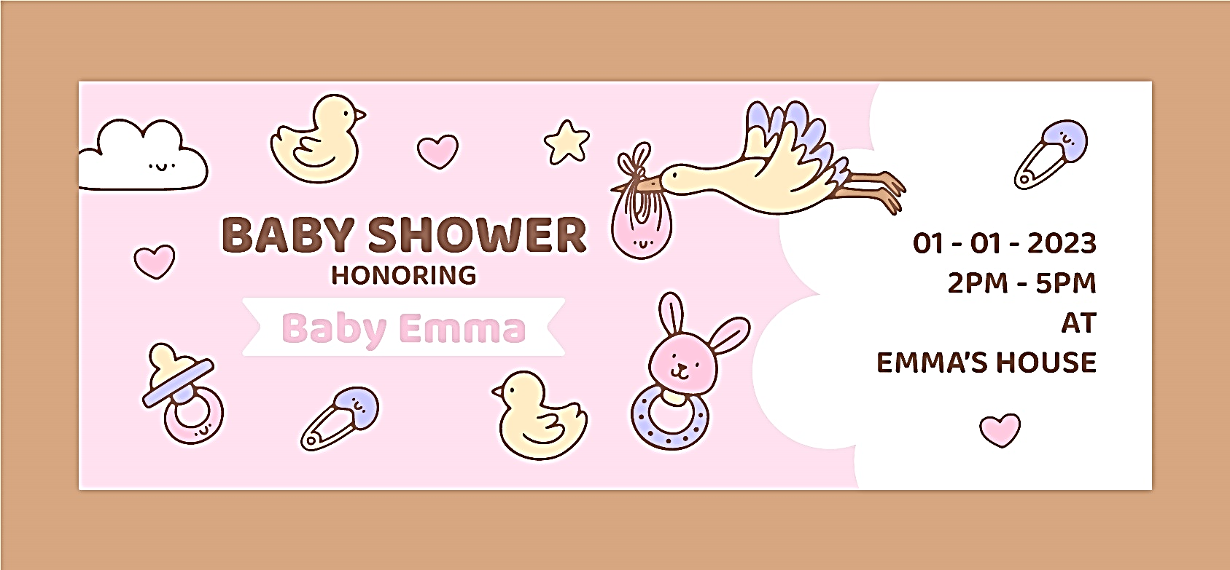
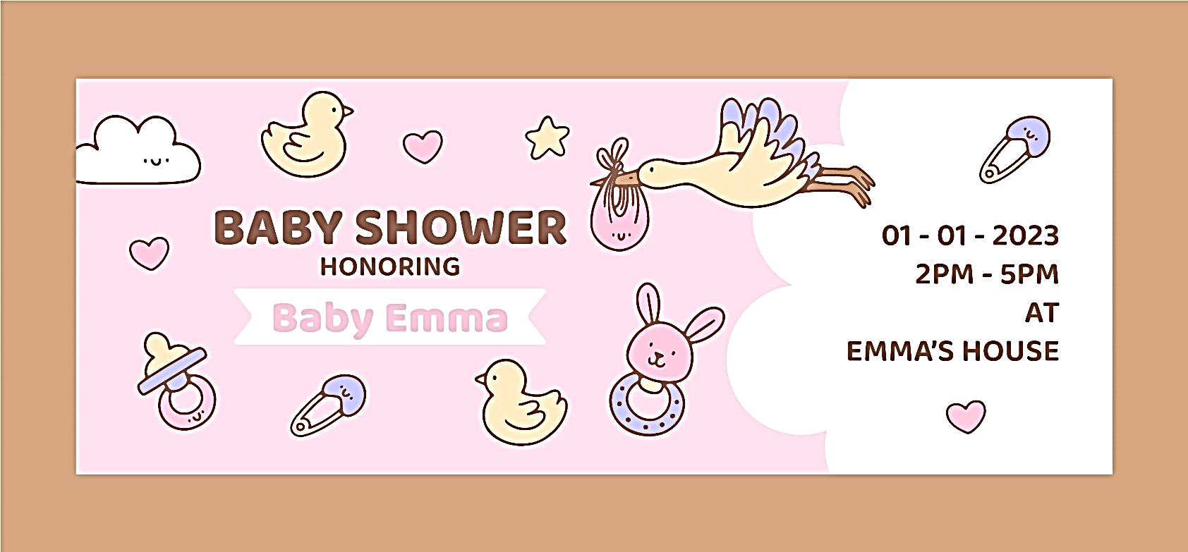
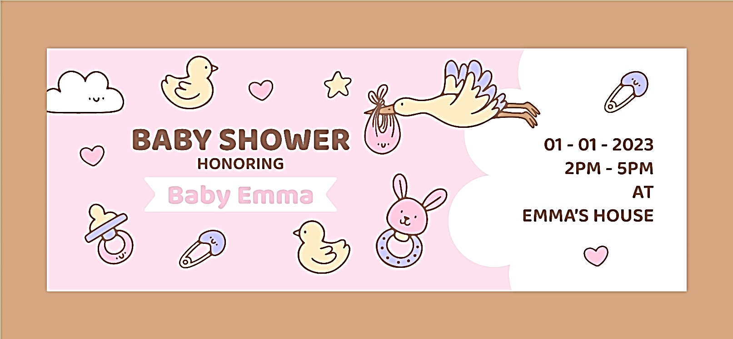
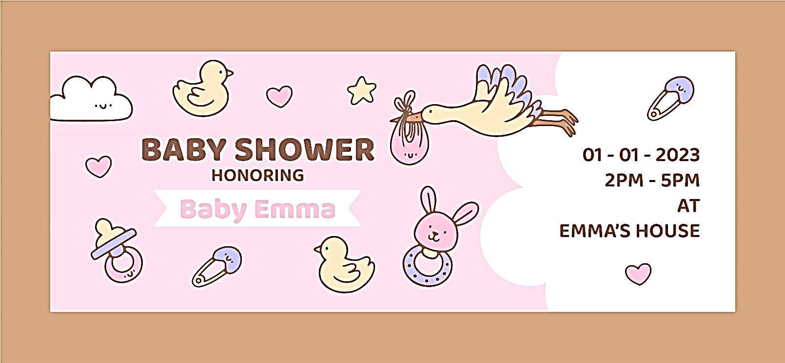
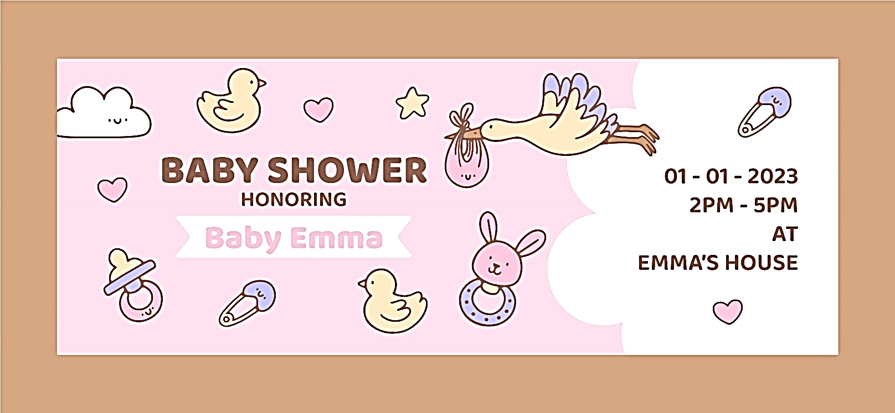
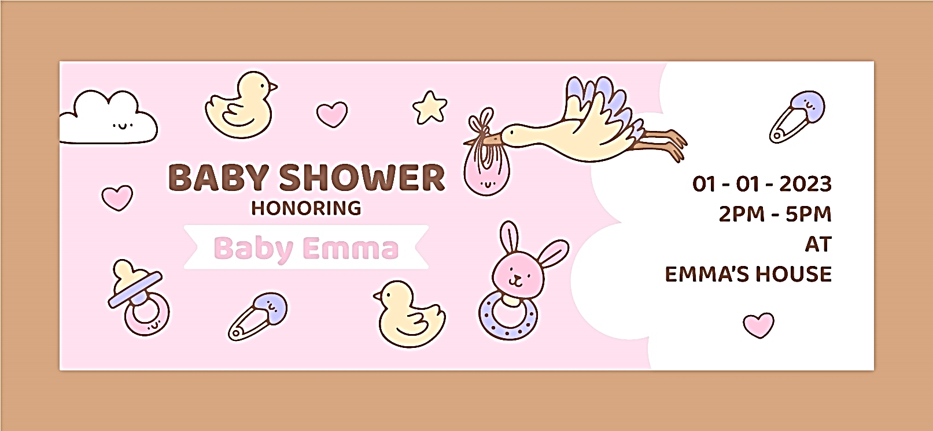
Baby Shower Guest List
Guest Name | Contact Information | RSVP
Guest Name | Contact Information | Yes | Maybe | No
Write here | Write here | ☐ | ☐ | ☐
Write here | Write here | ☐ | ☐ | ☐
Write here | Write here | ☐ | ☐ | ☐
Write here | Write here | ☐ | ☐ | ☐
Write here | Write here | ☐ | ☐ | ☐
Write here | Write here | ☐ | ☐ | ☐
Write here | Write here | ☐ | ☐ | ☐
Write here | Write here | ☐ | ☐ | ☐
Write here | Write here | ☐ | ☐ | ☐
Write here | Write here | ☐ | ☐ | ☐
Write here | Write here | ☐ | ☐ | ☐
Write here | Write here | ☐ | ☐ | ☐
Write here | Write here | ☐ | ☐ | ☐
Write here | Write here | ☐ | ☐ | ☐
Write here | Write here | ☐ | ☐ | ☐
Write here | Write here | ☐ | ☐
Write here | Write here | ☐ | ☐ | ☐
Write here | Write here | ☐ | ☐ | ☐
Write here | Write here | ☐ | ☐ | ☐
Write here | Write here | ☐ | ☐ | ☐
Write here | Write here | ☐ | ☐ | ☐
Write here | Write here | ☐ | ☐ | ☐
Write here | Write here | ☐ | ☐ | ☐
Write here | Write here | ☐ | ☐ | ☐
Write here | Write here | ☐ | ☐ | ☐
Write here | Write here | ☐ | ☐ | ☐
Write here | Write here | ☐ | ☐ | ☐
Write here | Write here | ☐ | ☐ | ☐

