

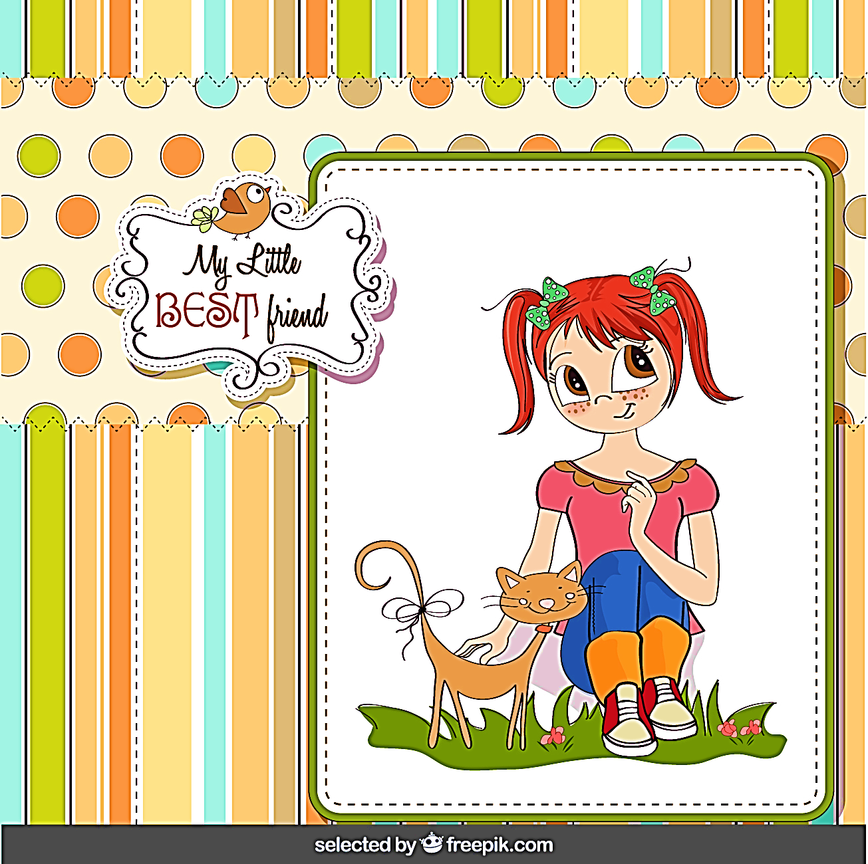
Weekly To Do List

 | Weekly-To-Do |  |  |  |  |  | Rewards |  |  |  | Shopping List
 |  |  |  | ☐
 |  |  |  | ☐
 |  |  |  | ☐
 |  |  |  | ☐
 |  |  |  | ☐
 |  |  |  | ☐
 |  |  |  | ☐
 |  |  |  | ☐
 |  |  |  | ☐
 |  |  |  | ☐
 |  |  |  | ☐
 |  |  |  | ☐
 |  | Notes

