
Standard Memorandum
Use the following standard memo template for most professional writing situations, including writing memos to your instructors for class assignments.

To: Recipients’ names and job titles
From: Writers’ names and job titles
Date: Complete and current date

________________________________________________________________________________________________________________
Subject: Description of what memo is about

Begin with a brief introductory paragraph that contextualizes the memo for your readers and describes the main point or course of action that readers should take after reading the memo. The introduction should not have a heading.
(Lorem ipsum dolor sit amet, consectetur adipiscing elit, sed do eiusmod tempor incididunt ut labore et dolore magna aliqua. Ut enim ad minim veniam, quis nostrud exercitation ullamco laboris nisi ut aliquip ex ea commodo consequat. Duis aute irure dolor in reprehenderit in voluptate velit esse cillum dolore eu fugiat nulla pariatur. Excepteur sint occaecat cupidatat non proident, sunt in culpa qui officia deserunt mollit anim id est laborum.)
After the introductory paragraph, the body of the memo should be broken into sections with informative headings at the start of each section. These headings should not consist of generic words like "Problem" but specific phrases like "Avoiding Cost Overruns in Sector 7."
(Lorem ipsum dolor sit amet, consectetur adipiscing elit, sed do eiusmod tempor incididunt ut labore et dolore magna aliqua. Ut enim ad minim veniam, quis nostrud exercitation ullamco laboris nisi ut aliquip ex ea commodo consequat. Duis aute irure dolor in reprehenderit in voluptate velit esse cillum dolore eu fugiat nulla pariatur. Excepteur sint occaecat cupidatat non proident, sunt in culpa qui officia deserunt mollit anim id est laborum.)

Remember that if there are others who will receive copies of memo, aside from the recipients,
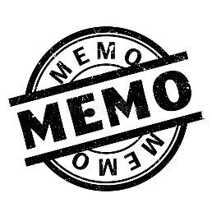
CC: (after the memo subject line with the names of those individuals.)
Attachment:

