
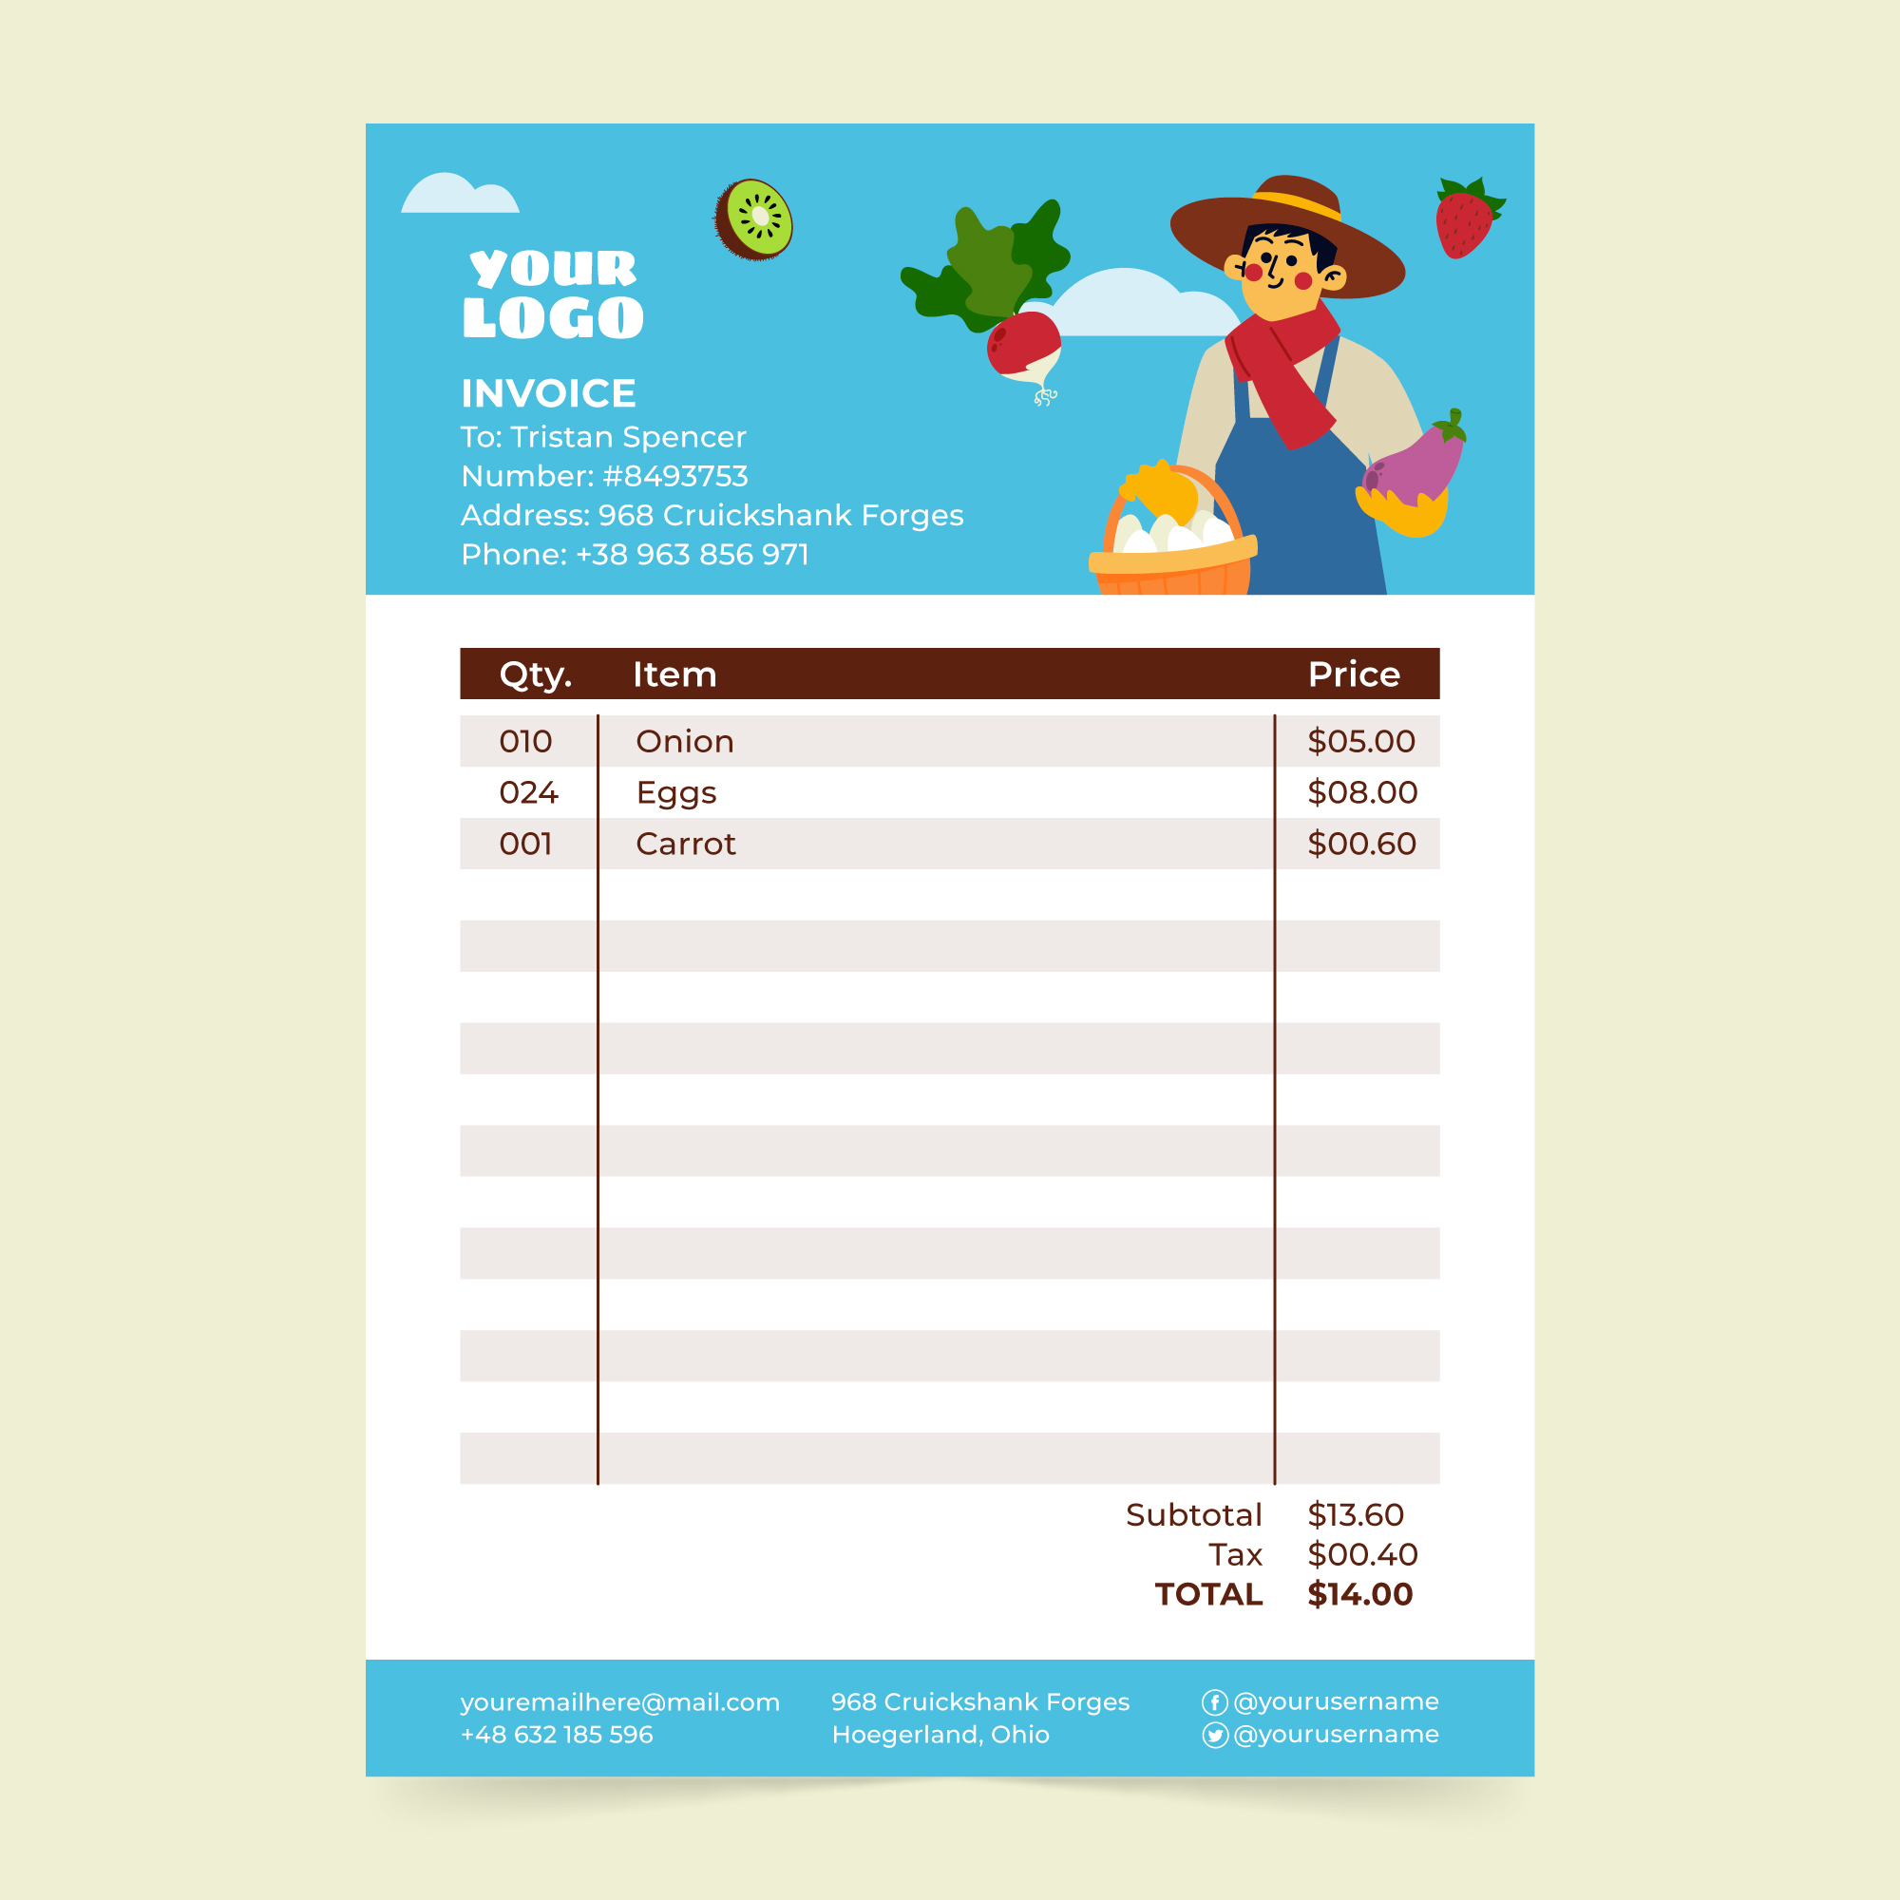
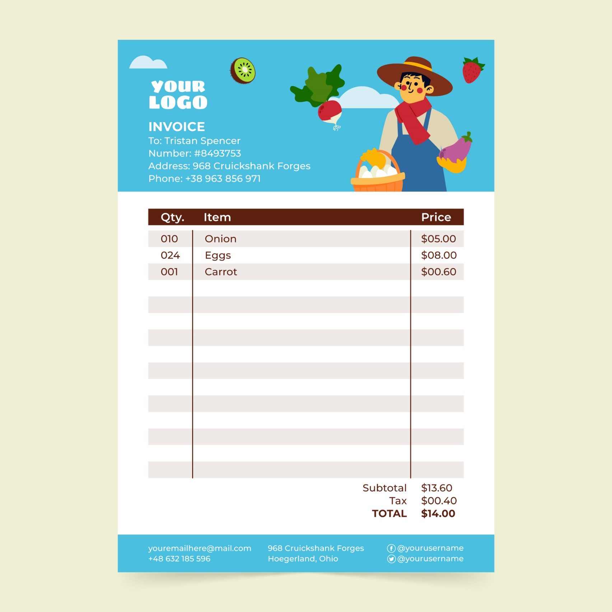
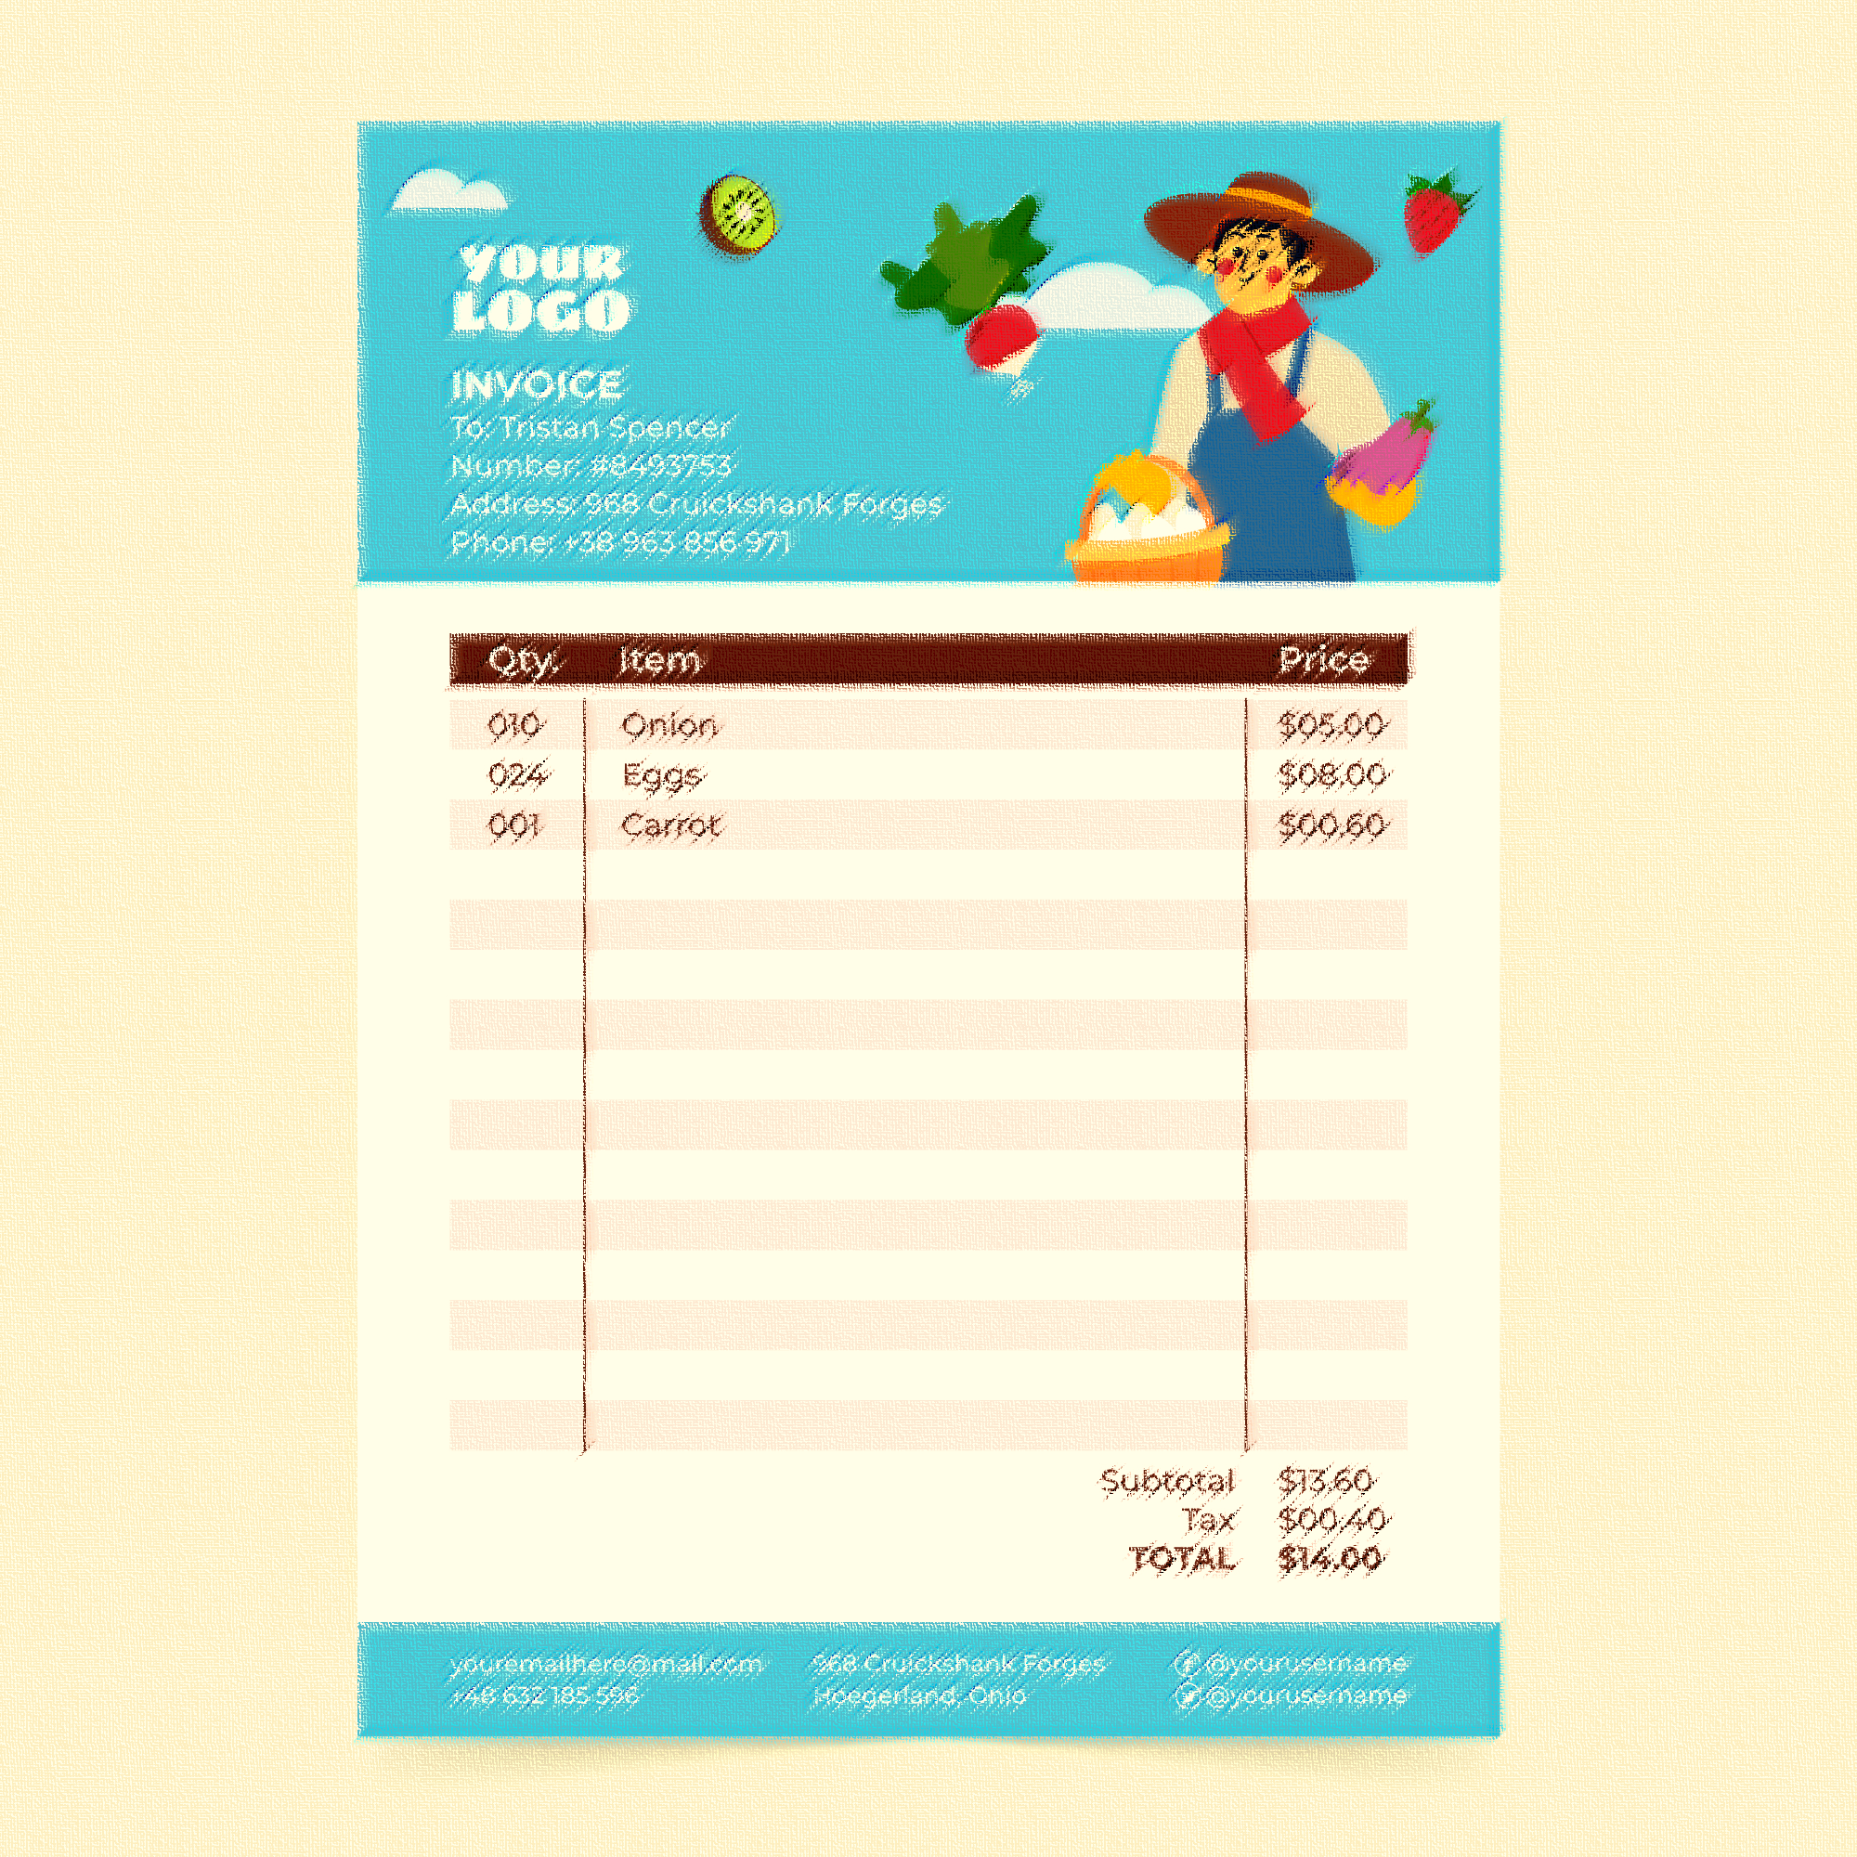

GROCERY LIST
WEEK : _______________________________________
FRUITS & VEGETABLES
MEAT, POULTRY & FISH
RICE / PASTA
CONDIMENTS & SAUCES
CANNED GOODS
DAIRY / DELI
SNACKS
BAKED GOODS
BEVERAGES
TOILETRIES
HOME SUPPLIES
OTHER

