
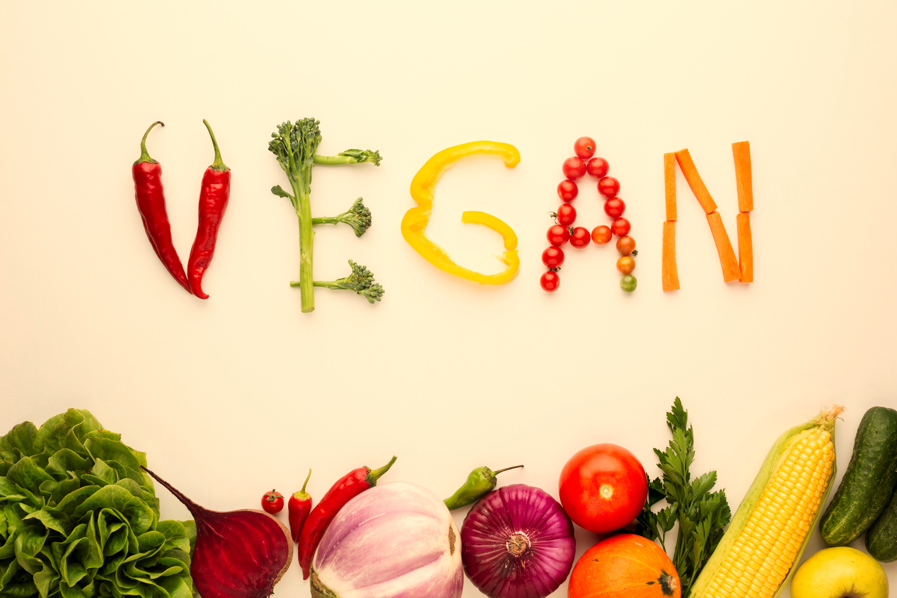
Grocery List
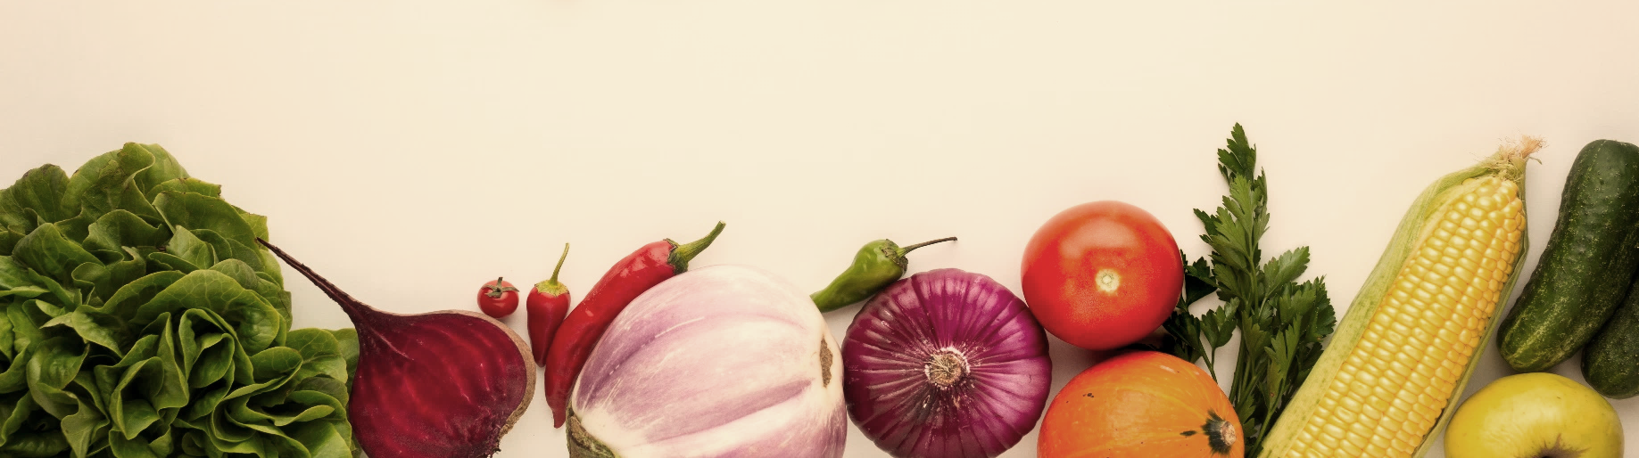
Dairy / Fridge | Baking / Dry Goods | Sauces / Condiments | Frozen
- Butter | - Oatmeal | - Mayonnaise | - Fruits
- Cheese | - Oil | - Mustard | - Ice Cream
- Heavy Cream | - Olive Oil | - Peanut Butter | - Juice
- Dips | - Coconut Oil | - Salsa | - Pizza
- Eggs | - Vegetable Oil | - Soy Sauce | - Potato Products
- Milk | - Shortening | - Steak sauce | - Vegetables
- Sour Cream | - Sugar | - Tarter Sause | - Other
- Yogurt | - Brown Sugar | - Vinegar | - Other
Meat | Canned Goods | Spices / Herbs | Fruits / Vegetables
- Chicken | - Canned Beans | - Black Paper | - Apple
- Ground Beef | - Canned Fruits | - Cinnamon | - Bananas
- Deli Meat | - Canned Soups | - Cumin | - Berries
- Fish | - Canned Peas | - Garlic | - Lemons / Lime
- Ham | - Tuna | - Onion Powder | - Onion
- Bacon | - Green Beans | - Oregano | - Potato’s
- Sausages | - Applesauce | - Paprika | - Spinach
- Pork | - Diced Tomato’s | - Parsley | - Cauliflower
- Hot Dogs / brats | - Corn | - Salt | - Zucchini
Baking / dry Goods | Breakfast | Beans / Pasta / Grains | Others
- Flour | - Cereal | - Beans | - Don’t Forget to
- Baking Powder | - Pancake Mix | - Lasagna | - Don’t Forget to
- Dry Milk | - Pop Tarts | - Noodle Mix | - Don’t Forget to
- Baking Soda | - Breads | - White Rice | - Don’t Forget to
- Food Coloring | - Eggs | - Brown Rice | - Don’t Forget to
- Chocolate Chips | - Syrup | - Lentils | - Don’t Forget to
- Cornstarch | - Biscuits | - Spaghetti | - Don’t Forget to

