
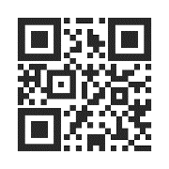
CUSTOMER NAME
Street Address
City, State, ZIP/Postal Code
Country
CUSTOMER NAME
Street Address
City, State, ZIP/Postal Code
Country
CUSTOMER NAME
Street Address
City, State, ZIP/Postal Code
Country
CUSTOMER NAME
Street Address
City, State, ZIP/Postal Code
Country
CUSTOMER NAME
Street Address
City, State, ZIP/Postal Code
Country
CUSTOMER NAME
Street Address
City, State, ZIP/Postal Code
Country
CUSTOMER NAME
Street Address
City, State, ZIP/Postal Code
Country
CUSTOMER NAME
Street Address
City, State, ZIP/Postal Code
Country
CUSTOMER NAME
Street Address
City, State, ZIP/Postal Code
Country
CUSTOMER NAME
Street Address
City, State, ZIP/Postal Code
Country
CUSTOMER NAME
Street Address
City, State, ZIP/Postal Code
Country
CUSTOMER NAME
Street Address
City, State, ZIP/Postal Code
Country

