
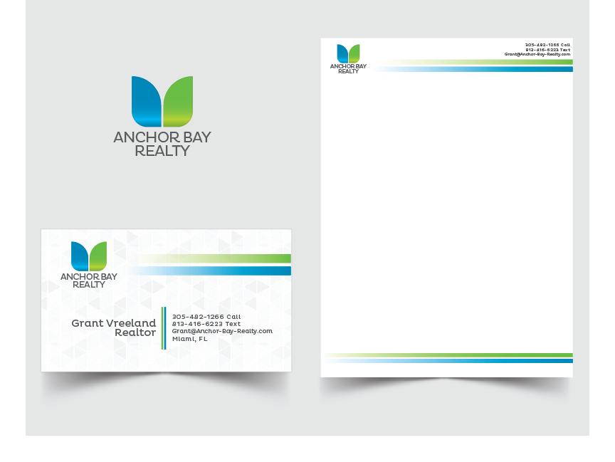

Employee Pension Plan
Company Name : Company Location: Write Location Here - Phone No – 12345678 - Email Address – www.abc@gmail.com

Date : 01-01-2023

Please provide the following requested items for Pension plans in which represented employees and/or their dependents participate.

We request all items be provided in an electronic format. For data tables, Excel spreadsheets or compatible formats are requested.

Pension Plan

- The three most recently prepared actuarial reports for funding and accounting

- The three most recently filed 5500 forms

- The following statistics, (which may already be included in the actuarial reports):
  - A cross-tabulated demographic breakdown of employees by age and service
  - Average credited service
  - Average age
  - Number of employees by pension band
  - Number of retirees and current average monthly benefit by years of service and year of retirement
  - Total pension liability, current service cost, and current interest cost attributable to active bargaining unit employees.

Savings Plan

- Please supply the total annual employer contribution to the savings plan for bargaining unit employees 2011 – 2023.

- For each job title and line of business, please provide the percentage of bargaining unit employees participating in the savings plan and the total annual employer contribution for 2011 – 2023.

