
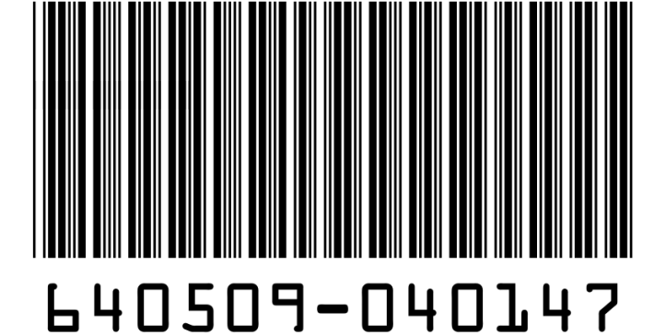

LOGO
Shipping From:
Company Name
Company Address
City – State – Zip Code
Contact No: 0900-123-456-77
Shipping To:
Company Name
Company Address
City – State – Zip Code
Contact No: 0900-123-456-77
Ship Date :
Lot Number :
Weight :

Dimensions
Length :
Weight :
Height :

LOGO
Shipping From:
Company Name
Company Address
City – State – Zip Code
Contact No: 0900-123-456-77
Shipping To:
Company Name
Company Address
City – State – Zip Code
Contact No: 0900-123-456-77
Ship Date :
Lot Number :
Weight :

Dimensions
Length :
Weight :
Height :

LOGO
Shipping From:
Company Name
Company Address
City – State – Zip Code
Contact No: 0900-123-456-77
Shipping To:
Company Name
Company Address
City – State – Zip Code
Contact No: 0900-123-456-77
Ship Date :
Lot Number :
Weight :

Dimensions
Length :
Weight :
Height :

