
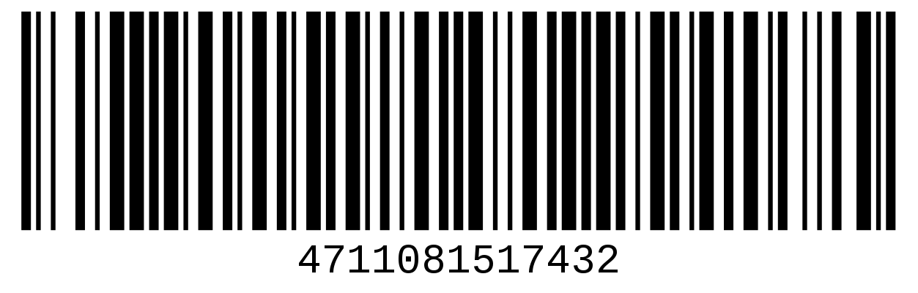
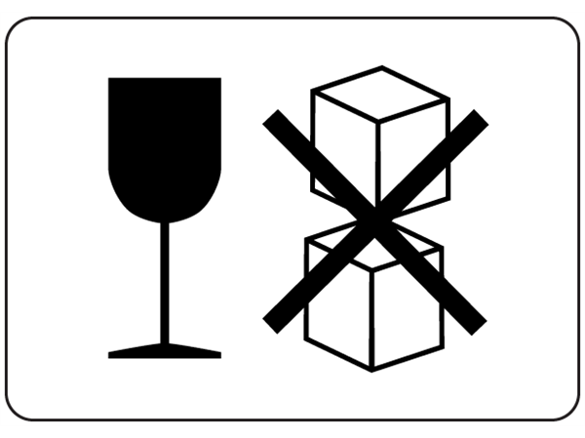

(LOGO HERE)

Tracking no:
00000-0000-0000-000

Shipping Date: 21-June-23
Weight: 290lbs

Shipping To:
(Type Recipient Name Here)
(STREET ADDRESS)
(CITY, STATE, ZIP CODE)

Shipping From:
(YOUR COMPANY NAME)
(YOUR STREET ADDRESS)
(CITY, STATE, ZIP CODE)

(LOGO HERE)

Tracking no:
00000-0000-0000-000

Shipping Date: 21-June-23
Weight: 290lbs

Shipping To:
(Type Recipient Name Here)
(STREET ADDRESS)
(CITY, STATE, ZIP CODE)

Shipping From:
(YOUR COMPANY NAME)
(YOUR STREET ADDRESS)
(CITY, STATE, ZIP CODE)

(LOGO HERE)

Tracking no:
00000-0000-0000-000

Shipping Date: 21-June-23
Weight: 290lbs

Shipping To:
(Type Recipient Name Here)
(STREET ADDRESS)
(CITY, STATE, ZIP CODE)

Shipping From:
(YOUR COMPANY NAME)
(YOUR STREET ADDRESS)
(CITY, STATE, ZIP CODE)

