
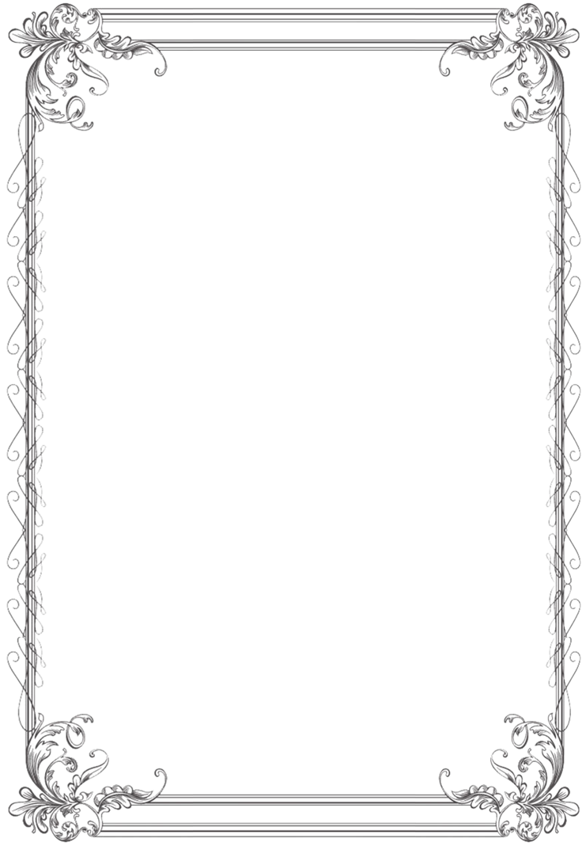
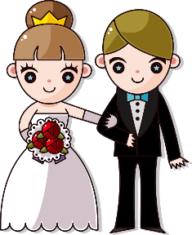
Wedding Gift List

Wedding Date: ______________________________
Name | Gift | Address | Status

