
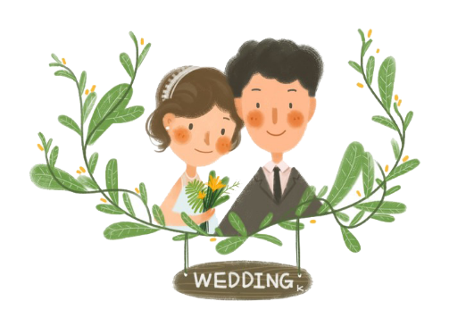
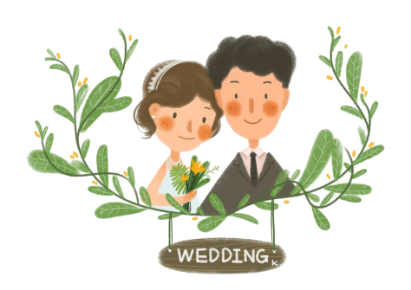
Wedding Gift List

Guest of Honor |  |  |  | Date of Wedding
Wedding Place |  |  |  | Time
Hostess |  |  |  | Co Hostess
RSVP Phone # |  |  |  | Number in Attendance
Gift Received |  | Gift Given By |  |  | Sent Thank You Notes

