
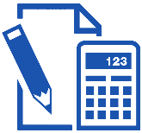
Retirement Plan Template
Write Company Name here - Address Here - Phone: 000-000-000 - www.abc@gmail.com

Appointment |  | Plan Eligibility |  |  | Plan Participation
Employee Information
First Name |  |  | Social Security Number
Last Name |  |  | Email-Address
Title |  |  | Home Area Code
Date of Birth |  |  | Home Telephone Number
Work Area Code |  |  | Work Area Telephone Number
Home Address: | City: |  | State: |  |  |  | Zip Code:
Contract Retirement Election

Optional Retirement

Acknowledgement
Employee Signature |  |  |  | Date
University Representative |  |  |  | Date

