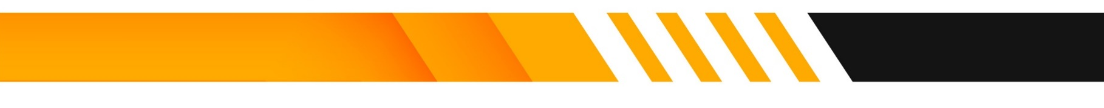


Sales Contract Template
(Sale of Automobile)

(The “Seller”) agrees to sell to ____________________________________ (the “Buyer) the (make, model, and year of vehicle) (the “Vehicle”), vehicle identification number _____________________________, in consideration for and pursuant to the following terms:
- The date of the sale of the Vehicle shall be _______________________ .
- The total purchase price of the Vehicle shall be ____________________ dollars ($________).
- On the day of the sale, the Buyer shall pay to the Seller the total purchase price of the Vehicle by cashier’s check, money order, or cash.
- The Seller shall provide to the Buyer the following documents upon receipt of the total purchase price on the day of the sale: the Certificate of Title, the current Registration, a Bill of Sale and Odometer Disclosure Statement, and a current smog certificate. The Seller shall be responsible for paying all past due registration fees and shall deliver the Vehicle to Buyer with a current registration and a clear title. The Seller also shall arrange to have all necessary smog inspections performed, at the Seller’s expense, before the day of the sale.
- The Vehicle is sold “as is,” and the Seller makes no express or implied warranties as to the condition or performance of the Vehicle.
- The Buyer shall register the Vehicle in his/her name with the California Department of Motor and Vehicles within one week of the date of the sale.

Executed this ___________________ day of _________, 20____________, at ______________________, California.
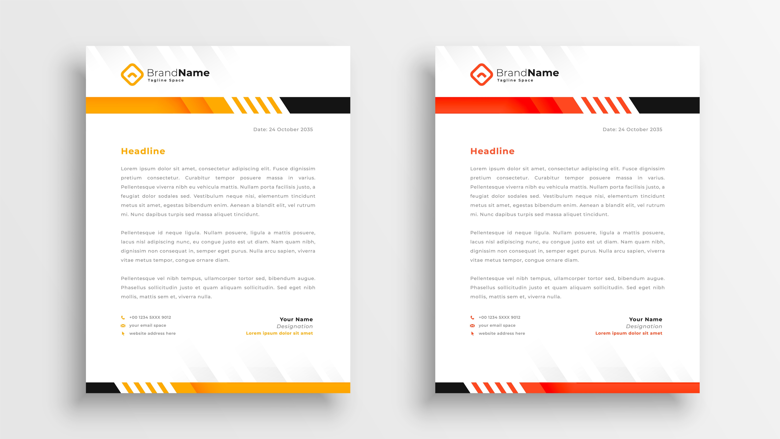
Seller :__________________________________ Buyer: ______________________________________

