

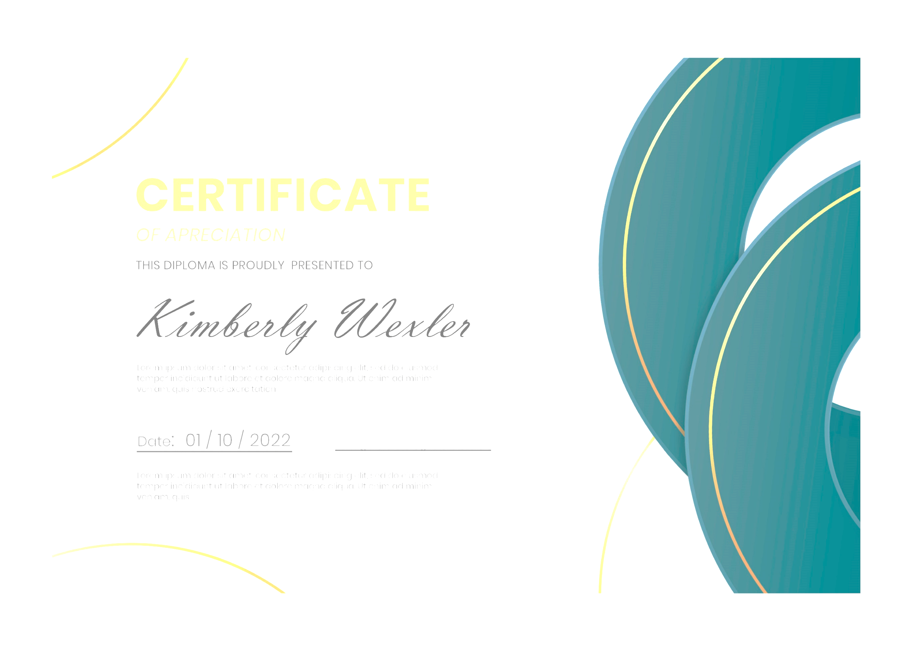
______________________________
Date
______________________________
Name of Presenter
Awarded to
Write Employee Name Here
_______________________________________________________
In recognition of your
Dedication, passion, and hard work
Lorem ipsum dolor sit amet, Consectetur adipiscing elit. Vivamus vitea luctus Leo, vitae. Dignissim quam. Sed placerat, neque in ele. Entum euismod, risus. Sed urna Purus, volute. Pat quis varius id, fragile non-urna.

Employee of The Year
CERTIFICATE

